 | 
UNIVERSITY OF ILLINOIS  AT SPRINGFIELD | ERICKSON & OPPENHEIMER, ltd.
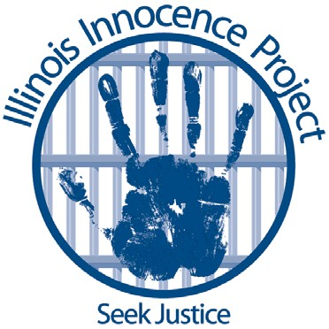

FOR IMMEDIATE RELEASE
Date: June 23, 2020
Contact: Lauren Kaeseberg, (773) 517-0622 (text or calls)
or Michael Oppenheimer (312) 343-0716 (text or calls)

Innocent man to be released from prison today, 13 years after
wrongful conviction for murder of his infant son

SPRINGFIELD – A Rock Island County man’s 2008 murder conviction was vacated and he will walk free from Menard Correctional Center today due to the efforts of the Illinois Innocence Project (IIP) at the University of Illinois Springfield and attorneys of Erickson & Oppenheimer, Ltd. (EO) in Chicago. Newly discovered evidence proves that Nathaniel Onsrud was not responsible for the death of his infant son.
Onsrud’s conviction was vacated after it was discovered that exculpatory documents were not disclosed to defense counsel that provided additional evidence that Onsrud is innocent. The Rock Island County State’s Attorney’s Office supported the request of IIP and EO to vacate Onsrud’s conviction and release him immediately.
“Our client, Nathaniel Onsrud, maintained from day one he had nothing to do with the tragic death of his infant son,” said IIP Chicago Legal Director Lauren Kaeseberg. “For the past 13 years, Nathaniel has fought to clear his name and has been through the unimaginable ordeal of losing his baby and then being wrongfully convicted of murdering him. We are so thankful that the State’s Attorney of Rock Island County has acted in the interests of justice and that we can bring Nathaniel home today.”
In May 2007, Onsrud’s four-month-old son, Dax, who had been born 10 weeks premature and had significant medical complications, became unresponsive while in Nathaniel’s care. After emergency medical treatment at home, Dax was transported to the hospital where he was pronounced dead a short time later.
Initial medical examinations did not reveal foul play and the forensic pathologist brought in to consult on the case was reluctant to determine the death was a homicide. After investigators focused on Onsrud, they had multiple meetings with the pathologist to devise a new (yet erroneous) theory – that he had caused Dax’s death. Onsrud was subjected to two interviews and finally, after continual questioning, made some ambiguous statements that the investigators determined was a “confession.” Ultimately, based in large part on this “confession,” Onsrud’s defense attorney at the time encouraged him to plead guilty.
False confessions played a role in the wrongful conviction of 96 individuals in Illinois – nearly 30 percent of Illinois’ 331 exonerations since 1989, according to the National Registry of Exonerations.
“To call this an injustice is a colossal understatement,” said Michael Oppenheimer of Erickson & Oppenheimer. “This was a grotesque, coordinated effort by corrupt cops, an unscrupulous and malicious prosecutor and a dishonorable medical examiner. They worked together, for the sake of their own careers – far outside all bounds of the law – to destroy an innocent man and his family forever.”
“However, I would like to commend the current Rock Island State’s Attorney, Dora Villarreal, for her dedicated leadership role in working to right this horrible wrong,” Oppenheimer added.
Nathaniel Onsrud is one of approximately 100 innocent Illinoisans whose cases have been reversed after they pled guilty, according to the National Registry of Exonerations.
“Our criminal justice system is fundamentally broken and we see that in large part in guilty pleas, where a vast number of people, once they are trapped in the system, take pleas to avoid hefty sentences threatened by the State,” said Kaeseberg.
In addition, Onsrud’s case is the latest example of the reversal of cases nationwide in which faulty science was used to convict innocent people where no crime had actually occurred.
Onsrud is the 15th client of the Illinois Innocence Project to be released or exonerated.

###

The Illinois Innocence Project, founded in 2001 at the University of Illinois Springfield, provides pro bono legal advocacy and guidance to those who have been wrongfully convicted in Illinois but have credible claims of actual innocence; educates students and the public about criminal justice system failures that lead to wrongful convictions; and works with policymakers and law enforcement to change rules, laws and practices to minimize wrongful convictions.

Erickson & Oppenheimer, Ltd. is a nationally recognized civil rights firm with over 45 years of courtroom experience, including significant wins in high-profile civil rights and criminal defense cases. Since its founding in 2004, Erickson & Oppenheimer, Ltd. has been dedicated to fighting for justice and compensation for those that have been wrongly convicted, maliciously prosecuted and the victims of police shootings and excessive force.

